**OpenIDEO case description**

*“People design better, together”*

According to the site,

*“OpenIDEO is a place where people design better, together for social good. It's an online platform for creative thinkers: the veteran designer and the new guy who just signed on, the critic and the MBA, the active participant and the curious lurker. Together, this makes up the creative guts of OpenIDEO.*

*To become a place where good ideas gain momentum, OpenIDEO depends on participation — your inspirations, his comments, her concepts, our design process. It's these efforts, these big and small moments of sharing and collaboration, that make this platform a dynamic resource for tackling significant global challenges.*

*IDEO, a design and innovation firm, developed OpenIDEO as a way to include a broader range of people in the design process through inspiration, concepting, and evaluation.”*

The approach of OpenIDEO to running the process is soft and indirect, and seems to be based on creating shared culture. Instead of direct tasks and explicit rules, the tasks are given indirectly and rules are enforced gently but firmly in the discussions taking place on the site. The approach used to create innovations has been termed collaborative competition: although there are winners, collaboration is encouraged in every turn. Apart from appreciation from the community, the winners do not get any rewards.

# Rules of OpenIDEO

Rules of OpenIDEO are a combination of a few explicitly stated principles, many culturally mediated implicit rules, and the legal rules of the site.

**Goals**

OpenIDEO is an online platform for creative thinkers who care about social good. It seeks to be inclusive, community centered, collaborative, optimistic and always-in-beta. Organizations and individuals can sponsor a challenge for social or environmental good. This is the place where translation of stellar skills into real world action is celebrated. Social impact is the big focus of the collaborative community at OpenIDEO and they’re keen on transformation of ideas to impact.

**Principles of the OpenIDEO Community**

***“Principle #1: Inclusive****Recognize and enable all levels of participation from different disciplines. It's about allowing anyone to contribute to the creative process. Whether it's a great insight, a beautiful sketch, an encouraging build, or a few words of praise, the platform allows everyone to take part in and feel as if they are a part of the process.”*

OpenIDEO aims to include all levels of participation from people with diverse backgrounds, as the real value is supposed to come from the diversity of participants. A veteran designer, the new guy who just signed in, MBA, active participant and curious lurker are all welcomed on the platform, as long as they are optimistic, creative, and like multi-tasking, collaboration and human-centered solutions.

***Principle #2: Community-centered*** *Remember the core strengths of the community and play to them. OpenIDEO is meant to foster a strong, vibrant, lively community that thrives on inspiration — and that we all trust will make a difference. Focusing on this community and its activities is essential.*

OpenIDEO is a community effort and users of the site are part of the team. Therefore it is crucial to foster a strong, vibrant and lively user community. The constructive role of the community is explicitly recognized in every turn and community and the ideas generated together are celebrated. Community members can join whatever way works best for them. They are a quite motivated, passionate bunch. Concepts generated are as good or bad as the community, and therefore it is up to the participants to spark and build.

***Principle #3: Collaborative*** *Promote teamwork among individuals and teams by recognizing the many roles that are crucial to each step of the design process. Always choose collaboration over competition, and create an atmosphere for building on one another's ideas.*

OpenIDEO is a collaborative platform: participants should choose collaboration over competition and build on the ideas of other. Despite the competition structure and selection of winners, collaboration is how OpenIDEO rolls.

***Principle #4: Optimistic*** *Stay optimistic! You never know when a wild idea might enable others to get closer to a viable solution.*

Attitude of OpenIDEO is happy optimism and “we can do it” attitude. Participants are eager to participate and they should stay optimistic, positive and respectful. They have fun and are excited and in celebratory mood when phases are switched. The participants should not feel shy, but instead pitch in to help each other out. It is practically guaranteed that someone will comment positively each contribution. As designers they need to find balance between pragmatism and optimism. Just because something hasn’t worked doesn’t mean it couldn’t work. It is important not to emphasize past but reframe where we’re heading.

***Principle #5: Always in Beta*** *Design for continuous improvement and iteration and scale deliberately. That goes for the community, the platform, and these principles. To this end, please email your suggestions for making OpenIDEO better.”*

**Conversation**

Collaboration loves conversation and people are a chatty bunch at OpenIDEO. The goal is to keep conversation optimistic, solution-focused and inclusive. Discussion should be kept to the target, to not diverge beyond the scope. The participants should feel free to ask, and in conversation use ‘and’ instead of ‘but’. The kind of conversation sets the tone for the ideas designed together. Comments are as valuable as concepts. The comments fuel onwards the development of concept – everyone has a place on the table. Good story deserves to be told well.

**Sharing, ownership & recognition**

Contributors own the concepts and license them to the challenge host. All concepts are shareable, remixable & reusable, similar to creative commons. Only trough sharing idea morphs, changes and becomes something strong. Winners are developed through collaboration: the high-flyers rest on the shoulders of everyone who’s participated in the challenge. Original sources should be acknowledged by using quotation marks and giving links to a source, and inspirations should be linked up to concepts by using Build on this –feature of the site. This gives the user more Design Quotient points and helps connect the dots. Other participants, who have commented on a concept, should be encouraged by letting them know their feedback will be included.

**Legal terms and conditions**

The legal terms and conditions seem to follow the standard approach of web sites. A small curiosity is that there appears to be two sets of terms and conditions: the general terms and conditions of the site, and challenge specific terms and conditions, which can overrule the general terms. For example, the general terms and conditions state that personal information of users will never be shared, unless stated otherwise in challenge terms and conditions. The participants own the intellectual property they have created on the site, but license it to the challenge sponsor. Concepts can also be freely used, shared and remixed, similar to terms of creative commons.

# Agents and user experience

It seems like the most of the users, or at least the prominent ones and the ones that are promoted on the site, are highly educated professionals and designers. Many of them work on jobs related to business development or design, or on an area related to specific topic of the challenge, such as mobile application development in rural India. The users of the site are definitely not a random sample of Internet users. Instead, self-selection favoring design professionals, higher education and social innovation seem to be at play. There is also a feeling that the site subtly encourages such self-selection, for example by presenting highly educated people with design or social innovation background on the blog.

**Experiencing the site**

The feeling of the site is lively, with lots of images and bright colors. At first it feels big and complex, but the size of the site soon turns out to be manageable. It is possible to scroll through all the submissions in a given challenge. There’s an atmosphere of happy optimism and we can do it –attitude.

According to users interviewed on the blog of the site there’s goodness, satisfaction and so much fun. The site is intense, inspiring and highly active, although posting the first concept can be intimidating, especially if the site is misconceived as a challenge or competition. Collaboration is mentioned as being the best part of the site. Being part of international community and immersed in a process, where ideas are created and translated them to impact on social good, can be inspirational. Community is committed to idea generation and participating is like being in the middle of a big design-jam-session. These descriptions should be taken with a grain of salt, as the source is the promotional blog of the site.

**Community**

For many participants the OpenIDEO community provides a venue to collaborate with a global community, which seems to be one of the reasons why people participate on the site. The social ingredient of meeting new people offers opportunities for bouncing ideas, learning from others and relating with own projects. Many of the participants are highly educated professionals and designers, who are described as being “crazy creative” and amazingly dedicated and talented. This might even be an obstacle for participating for some people; at least one of the most active members of the community reported being hesitant to participate at first because he didn’t have a design background. On the other hand the hard work and transparency are reasons why people are proud about the community and happy to be part of it. At least students respond to opportunity to connect and share with global community, although some people miss the ability to get in touch in more physical way with the participants.

The site is built to facilitate collaboration trough applauding and commenting. It offers opportunities to express and exchange random ideas and collaborate across disciplines. The constant community dialogue can help enhancing those ideas as the discussions in comment sections spawn new ideas, sometimes resulting in snowball effect as a result of sharing knowledge and resources. It is this community learning and sharing that makes the final concepts possible. Collaboration and diversity of the community also draws the participants further by potentially offering extraordinary experiences and pleasurable work during the challenges.

Again, the description is largely based on the interviews of participants featured on the OpenIDEO blog, so what is described might actually be the ideal of how the site is supposed to work.

**Feedback**

At OpenIDEO the feedback to users is immensely important. Getting constructive and encouraging comments inspires participants to think more creatively and can even get them hooked. Even if the participant didn’t end up winning the challenge, they can be winners by receiving positive feedback, which provides them confidence, validation and motivation. For example, if the participant is a little scared of doing prototypes, positive feedback can give her an ego boost. Users featured in blog posts describe posting a piece and seeing the resulting comments and collaboration as a wonderful achievement, and one of them was absolutely thrilled to see some of her concepts on the final list.

Instant feedback from virtual collaborators and knowing that someone is looking over their shoulder is an important motivational factor. In my personal experience, just a few positive comments and tips can make a big difference. The comments were thorough and the user had clearly put some thought and effort in constructing them. I ended up spending a couple of hours refining the concept I had posted in response to them. Without such feedback I definitely would not have worked on it on Sunday. In contrast, another concept did not generate similar feedback, and I never returned to work on it. I also developed a strong habit of checking My Contributions first when visiting the site, and often did it repeatedly during the day. Getting the first applause for a concept was uplifting, and a new comment was always exciting.

The overall feeling is that OpenIDEO does feedback very well. The facilitators reply to questions and suggestions, and users comment actively, too. According to one of the featured OpenIDEOers, someone is practically guaranteed to comment in a positive way. For instance, I got a response to a suggestion on new feature to the site in an hour. Although providing instructions (I had posted the suggestion to wrong place), the tone was very positive. The first person to comment my first concept was a facilitator of the site, and she complimented my concept on leveraging existing networks and on the included prototype. Although it seemed like a comment given to almost anyone, it still felt nice. The site features inspirations and concepts daily. In addition to displaying the featured concept prominently on the site, the announcement about the feature –status is posted to the comment section corresponding submission. For the user this kind of recognition is encouraging and generates a feeling of success, as I can personally testify. Getting a concept to shortlist and winning a challenge are apparently great successes for the participants. In addition to winners, often honorable mentions are also selected. A final, anecdotal example of long-term feedback is that OpenIDEO hires every now and then active users from the site to work for the company. Noticing that got me enthusiastic about the site for a while.

**Overwhelming and boring**

Participating to OpenIDEO requires a lot of motivation and effort from the user. Just hanging around half-heartedly is probably not enough to participate properly. In the beginning the site can feel overwhelming, and it is difficult to know where to start. Due to nature of issues discussed on the site it takes lots of effort already in the beginning: the user has to develop an understanding on the issue at hand before making any meaningful contributions, perhaps apart from applauding. Building real understanding on complex topic requires a lot of effort, and although short video (Youtube etc.) documentaries and presentations help, it would take long time to watch enough of them to really understand the nuances of the problem. In the challenges I participated I was left with the feeling I was only scratching the surface, and to gain real insights I should have worked much, much more. The same thing happened after inspiration phase, when users are supposed to come up with new concepts. The user has to figure out alone how to best use the contributions of other users. Going through the collected inspirations to build new ideas properly would take serious effort, even if looking at them in list format, let alone reading them and corresponding comments: one of the challenges feature 6 challenge themes with 353 inspirations. These feelings were reflected by some other participants of the site, too: one mentioned it being a bit overwhelming to see so many creative inspirations and concepts posted, and another was sure that everyone is finding it difficult being across all 106 concepts. Personally I found it most useful just scroll around the site and try to get a big picture of the issue based on the topics, attached images and short descriptions of inspirations and concepts. Developing a concept also feels like a lot of work. Some of the featured OpenIDEOers even mentioned scheduling freelance work to participate and give weekends to the challenges. All this makes one wonder how much the most active participants put effort on the site.

Refining the concept during the applause phase was easier, and here it was possible, at least for me, to leverage the community. I got a couple of comments and then asked for suggestions on how to develop the concept. This resulted in the two thorough replies mentioned before, pointing to many related concepts that could be used to improve my idea. Here OpenIDEO reduced the amount of work I had to do: instead of going through all the concepts by myself, I could rely on the community searching the relevant inspirations and concepts for me. I saved time when someone else read through and evaluated the content of the site. In the end I could develop an improved version of my concept by just combining the suggestions without caring much about the rest of the world. This approach did not require much brain power or thinking, especially when I used sticky notes to organize the pieces of the puzzle. An important question emerging from experiencing the site is what are the mechanisms that turn individual contributions to something more than sum of the parts?

For me the most common activity on the site is surfing and scrolling around. This can, and often does, get boring. Doing something meaningful on the site often requires the user to read through long descriptions of concepts and accompanying comments. It is usually not clear what would be the next task the user could easily take up and perform without serious cognitive effort. To summarize: trying to participate only little gets boring really fast, and participating properly requires lots of effort.

**Platform**

The OpenIDEO platform is organized around challenges. At the time of visiting, there were two challenges available, both near the end of concepting phase. Challenges, both ongoing and finished, are listed on a specific site. Clicking the challenge link anywhere on the site takes the user to the current phase of the challenge. The whole process is depicted visually on the prominent place on the site. It is clear, bright, immediately noticeable and gives a lot of information in an easy to access format. Each phase is described below the process chart in concise and easily understandable way. The whole site is very visual, and use of images is encouraged throughout. I noticed that images are important for grabbing the attention of the user while scrolling through the many pages full of inspirations and concepts. There is not always time to read even the topics or short summaries, so the interest is largely based on a good image getting the attention. Participants can join the challenges by clicking a grey follow challenge –flag, which according to one user “is obviously not enough”. It is not clear whether the user has to follow the challenge in order to contribute, but my current guess is no. The site does not give much instruction for the user on how exactly to start contributing, which can cause confusion. There are many, perhaps too many, possibilities, which makes it difficult to user to decide, for instance, what is the best way to browse and filter concept and inspiration lists. On the other hand, when the user has an idea or inspiration already in mind, the site does a good job in facilitating the submission process. There are big, friendly buttons with text “Add your concept” that directs the user to submission form. The form looks complete and well designed. There’s lots of space, the format is clear and even the challenge brief is easily available for review. There are seven main activities on the site the user can do:

1. Submit an inspiration
2. Submit a concept
3. Comment
4. Applaud
5. Refine inspiration
6. Refine concept
7. Evaluate shortlisted concept

At least according to one forum message by a user of the site, there is a difference between applause and evaluation. Applause is more about appreciation and positive feedback, while evaluation, performed only to the shortlisted concepts, is about critically assessing the value and feasibility of the concept. Although applause count may be used to support decision making, it seems like it is not the main purpose of the functionality.

**Bias**

The OpenIDEO platform has lots of potential sources of behavioral bias. Some of them may be intentional, some most certainly unintentional, some beneficial and some may be detrimental to the process.

**Displaying number of views, comments and applause.** I noticed I am strongly influenced by the number of comments and applause while browsing the lists of concepts and inspirations. Quite often the decision to open a submission for closer look is based on the high number of comments or applause it has gathered. This did not feel like having an effect on the decision to applaud. I was usually somewhat strict about giving applause. The site offers various filtering functions for browsing the content. The filters can bias the attention of the community towards the more popular and active discussions and potentially create feedback loops.

**Displaying user profiles.** User profiles are displayed on the site next to the concepts and inspirations they have posted. Recognizing a familiar user may have an effect on how the submission is evaluated. Many of the users are pretty women, which may have an effect on behavior of males. At least in one challenge the challenge sponsor (an organization, not an individual) submitted a number of concepts. For some reason community did not show much interest for them.

**Deadlines.** Deadlines clearly have an effect on my behavior. Closing deadline pushed me to submit a concept. On the other hand I felt regret for not posting it earlier, which would have given other users more time to collaborate around it. A deadline far away reduces the motivation to participate actively, especially if there are other things to do elsewhere. The descriptions of process phases direct the behavior towards activities most fruitful in that phase; for instance, I felt I should focus more on developing a concept instead of applauding as a result of seeing the deadline, description of concepting phase and the fact that applause would be the next phase.

**Featuring users, inspirations, concepts and tools.** OpenIDEO features good examples regularly, be they particularly active users, thoughtful inspirations, creative concepts or recommended tools to use during the challenges. User is subtly reminded of what desired behavior looks like. For instance, I realized I should have used Brainstorm-in-a-box toolkit during concepting after seeing it advertised on the site. A “leaderboard” of top contributors on various categories of activity is also displayed on the site, but most users probably never have a change to get on those lists, due to high scores of long-term regular contributors.

**Challenge themes and pattern recognition.** After the inspiration phase the facilitators post challenge themes to the site. They are based on grouping the inspirations and are supposed to direct the concept development to fruitful areas. Users can also figure out implicit themes on their own while browsing the inspirations and concepts; it is possible to see patterns in the data and get an impression of what kind of solution might be the answer. The personal biases of the participant may also be at play here. Being interested in online education, I noticed many inspirations related to education during one challenge, and found myself thinking about the solution only in the terms of online education. I also inferred a random comment on integration of education as support for my concept, which was about making a mash-up of currently offered courses on the web. Finding a concept that feels related to my own thoughts created a feeling I should build on it.

**Questions.** Challenge instructions, facilitators of the site and other users post many questions to the site. They direct the thinking and attention towards particular issues. A trademark questions of the site are the questions beginning with “How might we…”. This format is familiar already from older publications of parent company IDEO, for example the Human Centered Design Toolkit. “How might we…” questions are featured in challenge briefs, challenge themes, missions, and brainstorming instructions.

**Tasks and suggestions.** Tasks and suggestions given by other users and the facilitators naturally direct the behavior of the participants. I read through and considered all the concepts suggested to me in a comment even though I did not like most of them.

**Relatively high participation threshold.** The threshold for participating to the site feels relatively high, as described before: already getting started requires effort, and most visible participants on the site seem to be highly skilled. The result might be bias in self-selection to participate towards highly skilled and motivate users. Alternatively, the high threshold might also scare potential users away.

**Psychological biases.** Human beings have many well-known psychological biases. I found myself affected by some of them. Receiving a comment made me feel the need to reciprocate and write a nice reply. Opening and reading through a concept that I did not like made me feel I should still do something about it (applaud or comment), as I had already put so much effort on it (sunk cost fallacy at play). Misunderstandings may also bias the decision making. I applauded at least once a concept I had misunderstood. Being a researcher, the collecting data certainly changes the user experience.

**Learning**

The OpenIDEOers featured on the blog often describe the participating to the site as a learning experience. According to them the learning comes through the interaction with the community and feedback. Participating seems to teach especially design related skills: perceiving problems and thinking solutions, prototyping, tools and attitudes for idea generation, discovering new faces of design, learning to be creative in collaborative manner and letting go of ownership of ideas. The participants being from different backgrounds enrich the learning experience. The experience can be exiting for young designers, and may spark graduation projects for students, or even change the career plans of participants.

**Miscellaneous observations**

Sponsors supposedly pay a lot for running a challenge on OpenIDEO. But what do they actually get out of the process? Are the final concepts the real reason why they participate, or is the site perhaps another channel for marketing? Also at least some users seem to use the site for personal marketing. They post concepts and inspirations pointing to their already existing companies or organizations.

Many of the videos have DIY feel to them. An average user could probably create something of similar quality.

There are many workshops and other activities that take place outside the site during the challenge: OpenSTORMs, Make-a-thons and meetings.

# Feedback

Feedback is immensely important for the functioning of OpenIDEO site. The practices of giving feedback are rarely mentioned explicitly, but the amount of feedback on the site is large. There are two general sources of feedback: the site itself and its official representatives, and the other users. Feedback is given through written comments, blog posts and by displaying the numbers of comments and applause each contribution has gathered. Several flavors of feedback can be identified. These are presented in table 1. A stereotypical comment might look something like this:

*”Great concept! I like how it combines the ideas suggested by Tom and Jerry. Have you thought about how this could be used if electricity is not available? Thanks for sharing your thoughts!”*

|  |  |  |
| --- | --- | --- |
| **Category** | **Description** | **Example** |
| Official feedback | Feedback from the site or official representatives of the site | Congrats! This post is today’s featured concept! |
| Encouragement | Complimenting and giving positive feedback on the contributions of other users | Awesome concept! Totally believe in it! Keep it up! : ) |
| Reflection | Reflection on the comment or idea from different viewpoints, discussion about the implications and related stories | I agree with Meredith. In general, I think the best parts of a city should be exploited in a positive way. I know in the case of Spain, many of the younger students receive their education or pick up a trade, and go to a different country for work. I think it would be key to involve locals, especially the younger generation, and incorporate activities/events they want in a city. |
| Questions | Asking questions and requesting for more information or clarification | Do you have any specific ideas for what might motivate and ncentivize manufacturers to design in this way? |
| Thanks | Thanking other users about something they have done | Thanks to Amanda, Ally, and Sushmita for raising the security angle. |
| Acknowledgement | Acknowledging the contribution of someone else in discussion or submission | Angeliki’s concept of crowd-sourcing for small tasks is also really great, so along with the legal support net the “Assist” service should also incorporate a micro-tasking network |
| Rules | Feedback and instructions about the rules of the site and how people should behave | No apologies on a collaborative platform, Paul ;^) We’re all learning here – and you’ve certainly taught me a lot! |
| Tasks | Suggesting tasks in combination with feedback | Twitter based medical care sounds like a great idea! Consider posting it in our Concepting section |
| Mission accomplished | Announcing what has been done, often in response to suggestion to take an action | Nice find (with the timberland green index)! I’ve added a shot of that to this concept |
| Applause | Applause given to inspirations, concepts and comments. Similar to like-button on Facebook | Applaud-button, number of applause visible at the site |
| Number of views and comments | Quantitative feedback on attention and interest | Number of views and comments visible at the site |
| Evaluation | Challenge specific evaluation of shortlisted concepts | Multiple-choice questionnaires and bar-charts |

Types of feedback

**INNOVATION PROCESS**

The innovation process of OpenIDEO is distributed over three environments: organization, platform and community. Organization consists of employees of OpenIDEO and challenge sponsors. Platform is the OpenIDEO website, including the content. Community consists of the participants of the site, who each have their own profile. Employees of OpenIDEO play a dual role: they work both behind the scenes in the organization, and out in the open as participants in the community. Representatives of the sponsor may also participate in the community with their own names or through a profile created for the organization.

The innovation process has several well-defined phases. Except for early variations, the structure of the process has remained stable from challenge to challenge, although depending on the challenge some of the states may be left out. Explicitly stated phases of the process are the following:

1. Challenge Brief
2. Inspiration
3. Concepting
4. Applause
5. Refinement (sometimes left out)
6. Evaluation
7. Winning Concepts
8. Realisation (sometimes left out)

In addition to the public phases of the process the process contains also implicit phases taking place behind the scenes. The full process, including implicit phases is the following:

1. Challenge design
2. Challenge brief
3. Inspiration
4. Synthesis meeting
5. Concepting
6. Applause
7. Shortlist selection
8. Refinement
9. Evaluation
10. Decision on winners, reporting
11. Winning concepts
12. Implementation by sponsor and participants
13. Realisation

Several of the phases contain parallel activities taking place outside the site.

**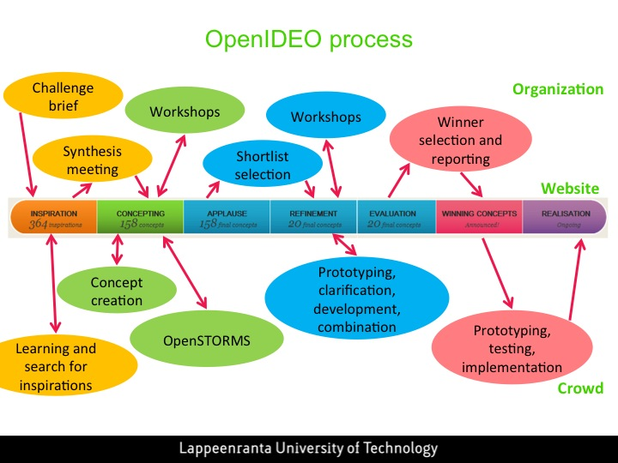**

The OpenIDEO process.

**Rules of innovation process**

At OpenIDEO innovation process is considered to be a collaborative learning process. Sharing of information and collaboration are encouraged over competition. Each phase has a deadline, before which the contributions to that stage have to be made.

1. Innovation is a learning process.
2. As always on OpenIDEO, challenges represent journeys where each plays an integral part in shaping the outcome
3. Innovation process is a little bit about relinquishing control to that sacred idea you never shared
4. Less than a week to go to post your examples

**Tasks during the innovation process**

Depending on the phase of the challenge, users can

* Post inspirations (Inspirations phase)
* Post concepts (Concepting phase)
* Update their own, shortlisted concepts concepts (Refinement phase)
* Evaluate concepts (Evaluation phase)
* Comment on blog posts, inspirations and concepts (any time)
* Applaud on blog posts, inspirations, concepts, and comments (any time)

Commenting and applauding are possible in every phase and even after the challenge has ended. Other activities are possible only for a limited time, during the corresponding phase. There is a specific, defining task for almost every phase of the process.

# Challenge design

The activities on the site are organized around challenges. The challenges are difficult design tasks, which usually are related to some large and complex environmental or societal issue, such as food production, health care, or unemployment. OpenIDEO receives the funding to run the challenges from challenge sponsors, who can be organizations or individuals. The sponsor pays the costs of running the site and the salaries of the facilitators. Although I haven’t found an explicit description, I suppose that the challenge is designed in collaboration between representatives of the sponsor and employees of OpenIDEO. The resulting challenge brief is posted on the site, which marks the beginning of the challenge.

“Organizations or individuals can sponsor a design challenge, as long as it’s for social or environmental good. All OpenIDEO challenges require financial sponsorship to help underwrite our own costs associated with managing the challenge and providing tech and community support.”

# Challenge brief

Challenge brief describes the design task at hand and marks the beginning of the challenge. It is usually a combination of short written description and a few minutes long video featuring a representative of the challenge sponsor. Challenge brief shortly describes the problem and context, explains why the issue is important and states the general goal of the challenge. The sponsor of the challenge is also presented. OpenIDEO typically features complex, ill-defined problems, for which it is unlikely that a single solution exists. The challenge brief does not give exact criteria for a successful solution. Important part of the design task is to figure out what exactly is the problem.

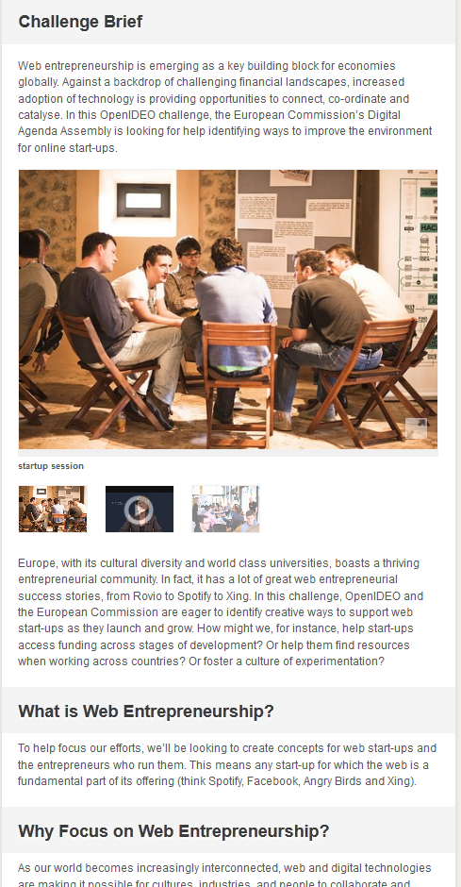

## Rules

## Tasks

# Inspiration

Inspiration phase consists of two related tasks: learning as much as possible about the problem and finding examples of solutions that have worked elsewhere. The challenge brief only gives a short introduction to the issue and it is the task of participants to figure out what exactly should be solved and how. During the inspiration phase the problem is defined in multiple ways in inspirations posted and comments to these inspirations and the challenge brief. This phase is in essence about preparation for idea generation following in the concepting phase, as OpenIDEO deals mostly with ill-defined, large social or environmental issues, for which a single solution is unlikely to exist. The main task of the participants is to post to the site anything interesting with a specific inspiration form, as long as the content is related to the challenge brief. Inspirations may contain definitions of the problem, such as short videos describing some aspect of the issue, personal experiences, or existing solutions to a similar issue.

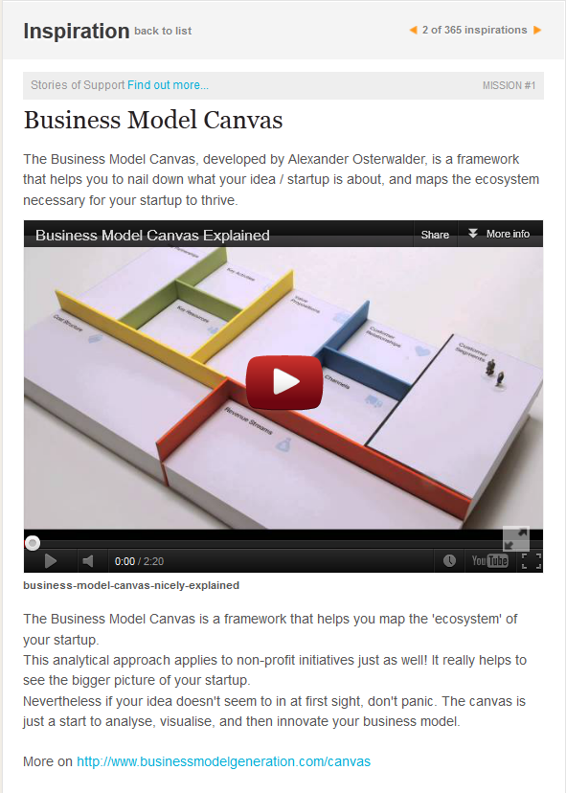 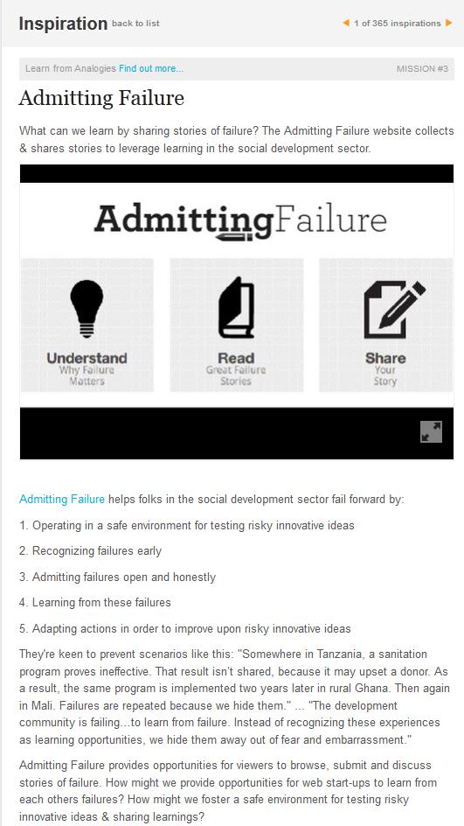

## Missions

Missions are challenge-specific tasks to be performed during the inspiration phase. They give participants more detailed instructions on what kind of activities to take on during the inspiration phase. Missions are given rather indirectly in the side bar of the site and user can participate in them as they wish. Inspirations can be tagged to missions, which seem to be the only way how the completion of missions is tracked. Often missions are about finding out more about the issue, revealing personal experiences and stories, and finding working solutions to similar problems. The most often recurring mission is Surprise us, under which OpenIDEO asks to submit almost anything interesting, even if it was not that closely related to the challenge.

|  |  |  |
| --- | --- | --- |
| **Type of mission** | **Description** | **Example** |
| Personal experience | Stories about personal experiences related to challenge theme | **Mission #1 Share Your Election Story**  Have you participated an election before? In what way did you participate (learning about the election, registering to vote, casting your ballot, volunteering as a poll worker, or others)?  Tell us about your experience: What was fun? What was confusing? If you haven’t participated in an election before, why not? What barriers got in your way? How could the process have been made easier, more interesting or more compelling to you? |
| Existing solutions | Examples of already existing solutions to similar issues and descriptions of approaches that have worked elsewhere | **Mission #4 Learn from Analogies**  Let’s find inspiration in analogous examples to help us learn more about e-waste. Analogies can be especially helpful in highlighting innovative solutions from other sectors, issues or industries that might also have applications for our challenge here.  What might we learn from the success of consumer-facing anti-smoking campaigns, for instance, that could inform our e-waste ideas later on in the Concepting phase? What parallel companies, services or systems can we learn from to better understand and approach what e-waste is and how to manage it responsibly? |
| Learning about the problem | Learning about the issue at hand, usually from the perspective of users | **Mission #2 Day in the Life of a Start-up**  Talk to someone you know who runs a start-up, or has in the past, and ask about their experience. For instance: ask them to draw a timeline of the highs and lows of running a start-up. What surprised them the most about their experience starting up a company? If there were a start-up genie in a bottle, what three wishes would they have? Maybe you can even hang out at their office for a day and let us know what it's like there.  And if you've started a web company, a new venture, or even a new club, tell us about it! What were the needs of your organisation in its early stages? What were your struggles, opportunities, or concerns? You might also think back on an anecdote that highlights a particular challenge: what was the issue you were facing and how did you overcome it? |
| Try it out | Get active and try out some aspect of the challenge for real | **Mission #4 Get Active**  Grab some friends and head out to experience your own city or community – attend a public concert, ride public transportation, enjoy some local green space – the sky’s the limit! What did you try and how did it feel to connect with your community in that way? Did you find evidence of vibrancy and/or decline during your activity? What did you learn? |
| Defining concepts or keywords | Exploring the meaning of some essential keyword or concept related to the challenge | **Mission #4 Exploring Social Business**  For this Mission, take a moment to think about broadly about social business and how you’d define it. How is your definition similar to or different from [the Seven Principles](http://www.grameencreativelab.com/a-concept-to-eradicate-poverty/7-principles.html" \t "_blank) outlined by Muhammad Yunus, founder of Grameen Bank?  Once you have an idea of what social business is, think about what people and organizations are championing the idea of social business around the world. For the time being, we encourage you to look beyond health and instead consider examples across sectors and social issues.  Some questions to tackle:   * What does social business mean to you? * How would you represent social business using images, videos, or other visuals? * What inspiring examples of social businesses have you heard about? * What might we learn from their successes or challenges? |
| Surprise us / Inspire us | Anything that might be relevant to the challenge but does not fit the other missions | **Mission #5 Surprise Us**  What have we missed? Inspire us with insights, examples and stories that go beyond our other missions. |

Typical missions featured at OpenIDEO.

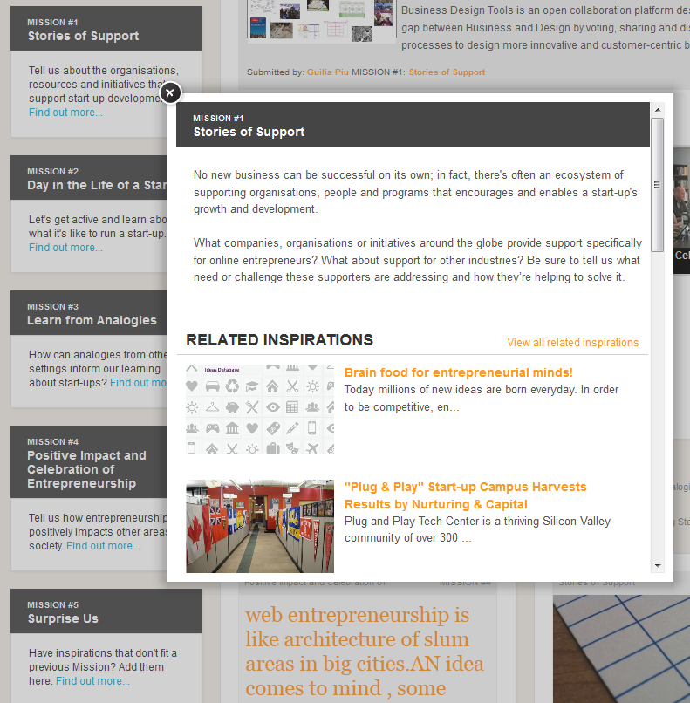

## Rules of inspiration phase

1. To be innovative we need to know as much about the problem as possible
2. Remember: inspiration phase is about exiting initiatives, examples & insight
3. “Before jumping head in with solutions it would be important to understand the problem”
4. We have to learn about the problem
5. Research, learning, questioning, exploring – these are all actions of inspiration phase
6. Inspiration phase of a challenge is not the idea phase
7. While it’s tempting to start thinking of ideas now… (don’t!)
8. Only then do we start thinking about how we might help
9. Designing with user needs in mind. Inspiration phase used to learn more about who they are

## Tasks in inspiration phase

1. Watch the intro video
2. Check out tips at Inspiration: Low-down
3. Join in to share and discuss across our range of missions
4. Questions, we’d like you to answer: <list of questions>
5. Swing by inspiration phase, add examples, join conversations, and help tease out the topic
6. Unpack your inspiration for community
7. Consider adding that particular comment as an inspiration
8. Don’t forget: \*real\*conversation is going on over the inspiration phase <link> We’d love if you join
9. Do NOT post your ideas yet!
10. Feed the idea and let it grow: jot down your thoughts and park them for now

## User experience in Inspiration phase

I found it difficult to understand the functionality of missions. Part of the reason for this was probably that I joined the first challenges when they were already in concepting phase. When I later participated to inspiration phase of another challenge, the missions made instantly much more sense. The missing piece had been the big, friendly orange button with a text “Add your inspiration”, attached to each mission description. Missions can be completed, or at least participated to, by adding inspirations to them. The tasks contained in missions felt reasonably sized, at least compared to tasks in refinement phase. Most of them can be carried out without understanding everything and by relying only on personal experience. Still the missions feel quite big and hairy. I can’t instantly jump into action. Instead, some effort and thinking is required to figure out what exactly is asked for in the challenge. The tasks are cognitively demanding, and there are many of them. I wondered whether I should select one of them and try it out, or see what others have already submitted.

**Creating inspirations**

I checked the brief for the challenge “How might we identify and celebrate businesses that innovate for world benefit – and inspire other companies to do the same?” To my surprise, there was no video this time. The site already had 275 inspirations (total for this challenge was 456 in the end), which was kind of scary. I finally figured out how collaboration map user interface works, but still did not find it very useful. I read through the guiding principles for this challenge. They seem to be challenge specific. I’m growing frustrated at the size of tasks on OpenIDEO. The user needs to understand a lot to participate. There are not many cognitive shortcuts for the user, which would allow her to understand the issue at hand faster and more efficiently than when she is working alone. Collection of information is probably more effective, but every user still has to go through a large part of it to gain necessary understanding. I browsed through all the inspirations submitted so far in list view to get an overview of the big picture. Hopefully my subconscious mind picks up some interesting patterns.

The next day I browsed through all the notes related to sustainability, business and environment on my Evernote. I found two interesting notes, which I turned to inspirations for the challenge: sustainability in NASCAR, and Sustainable business special report by MIT. Something reminded me of a TED-talk by Derek Shivers, which I added as an inspiration, too. Creating inspirations was fun and easy, but quite time consuming. I basically just used copy-paste, added links to original source and decorated the submissions with images from Flickr or my own albums. The end results looked pretty.

**Applauding inspirations**

In addition to adding inspirations I also took on the task of applauding inspirations submitted by other users. It was not requested anywhere, but for some reason I felt I should do it. It turned out to be unfeasible to browse through all the inspirations alone. Just browsing in list view takes effort and gets boring quickly (15 min). Concentration and interest to the task are lost. I figured it is much more useful to use the default filter Fresh and surprising, which randomizes the order in which the inspirations are presented. I applauded the inspirations I found interesting, most of the time just based on the image, headline and short summary. I browsed through about 160 inspirations, at which point I did not really care anymore about what I was doing. I was barely looking at the images. In my experience applauding is subjective and my criteria for giving an applaud varies a lot. Some of the reasons I had for applauding include

* Did not like the video, but it’s message was kind of against the challenge
* Inspiration is according to specifications of the mission
* Gangnam style mentioned!
* Inspiration had been requested, and someone delivered.
* Definitely liked the inspiration
* It was a featured inspiration
* Applauded just because. It was sort of a protest, as it was the first applause for this inspiration

At one point I even applauded low-down on inspiration phase, even when it doesn’t change anything. I don’t know why I did it. My experience was that I was doing a poor job at applauding. I didn’t really care about what I was doing, and it felt like I would have to do a huge amount of applause before it had any real effect. It felt like just applauding did not really matter, and no matter how much I applaud, there will still be a huge number of inspirations left.

# Synthesis meeting

After Inspiration phase the OpenIDEO team, possibly with the help of representatives of the sponsor hold a synthesis meeting, where they group the gathered inspirations under the emerging themes. The themes and accompanying descriptions are then posted to the website at the start of the concepting phase. The team may also define a set of design constraints or other further instructions for the concepting phase. Since the sixth challenge (How might we improve maternal health with mobile technologies for low-income countries?) the concepting phase has been accompanied with challenge-specific Brainstorm-in-a-Box toolkit. The toolkit is presumably created behind the scenes in later stages of the inspiration phase.

## Rules

## Tasks

1. Step back and review community process
2. Figure out how to best move forward to concepting
3. Assemble a great group for synthesis meeting
4. Prepare for meeting by taking stock of inspirations and starting to think about common themes
5. Group inspirations into challenge themes
6. Provide design constraints

# Concepting

The main goal of concepting phase is to generate new ideas for solutions to the issue that is the topic of the challenge. The concepting themes give direction to concepting, and content and discussions from inspiration phase are supposed to be used to point at possible solutions. User are asked to take all the learning from inspiration phase and use it to generate new ideas, which are then posted to the site using a particular concept form. The form gives implicit instructions to the user on what to include to the concept. The empty fields, questions and possibilities for uploading content all provide hints on what is expected from a good concept. Visual approach and use of pictures is heavily encouraged; the site facilitators regularly post a comment encouraging the user to add visuals to concepts lacking them.

**Themes**

Usually the facilitators combine collected inspirations to challenge themes, which are supposed to give directions to concepting. Usually there are around half a dozen themes. How might we… questions are sometimes used.

|  |
| --- |
| **Make the Business Case**  Our challenge focuses on the environmental and social impact of e-waste, but it’s important to consider e-waste from a business lens too: what's the business case for responsibly and safely managing e-waste and discarded electronics? As we learned in [our interview with Green Citizen](http://www.openideo.com/fieldnotes/openideo-team-notes/exploring-e-waste/), businesses can make a dent in the e-waste problem and make money – but doing so can require large investments and high-level commitments from everyone involved.  *What business models can we design to help companies to ‘do good’ in the world of e-waste?*  *How can business work with governments, nonprofits and other partners to create large-scale impact?*  *What efforts internally and externally can companies undertake to help their employees and customers make smarter electronics purchase and recycling decisions?* |

Example of a theme from How can we manage e-waste & discarded electronics to safeguard human health & protect our environment challenge

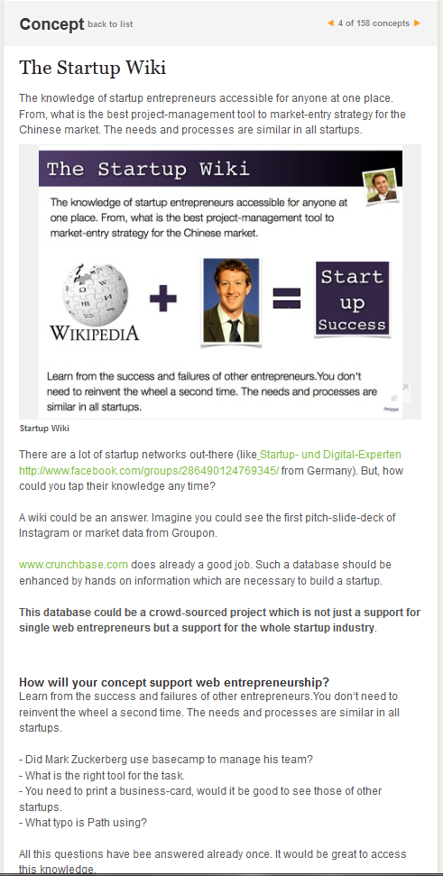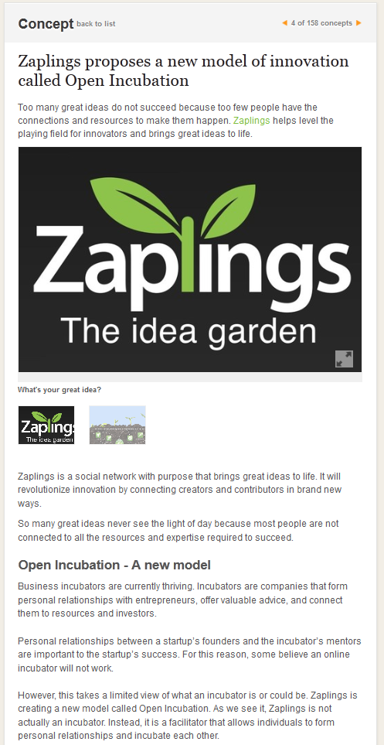

## Rules of concepting

1. You’ll get a change to exercise your concepting dexterity in next phase (this one)
2. Concepting phase – it’s about having trust in collaboration
3. As always on OpenIDEO, these starter concepts are here to build upon
4. Think bottom-up, top-down and side-to-side
5. Embrace out of the box notions & build, build, build
6. We pose questions & provocations so that ideas can get to a better place
7. Be visual, it’s all about the idea behind the sketch
8. Remember: the more visual you can make your post, the better

## Tasks related to concepting

1. Swing by concepting phase, take a look, join conversations and generate fresh posts
2. Take everything we learned during the inspiration phase and use insights to develop our own innovative ideas to challenge question
3. Check out all the goodness collected during inspiration phase
4. Check out the latest challenge news
5. Check out our guiding principles for this challenge
6. Check out our tips for concepting
7. Take into account design constraints, such as offering various price points, supporting independence and don’t forget about the people
8. Take some time to sketch out your thoughts
9. Use this guide to brainstorm on your own
10. Give OpenStorm a try! Grab some friends, the toolkit and hold your own OpenSTORM and join the fun!
11. Check out these tips on using OpenSTORM and Brainstorm-in-a-box.
12. Keep sketches and illustrations coming
13. Contribute more of your thoughts either as concepts or joining in conversation on other concepts
14. Bring on the collaboration!

## User experience in Concepting phase

**Understanding the challenge**

I joined the OpenIDEO site when two challenges were in concepting phase. The first task to do at this point was figuring out what the problem is. Best way for me to do this was watching videos such as documentaries on e-waste and TED-talks for the details and deeper understanding, and browsing the inspirations in list view to get the big picture of the issue at hand. Before creating solutions it is necessary to understand the underlying patterns. The only way to do it on OpenIDEO is to personally study the problem. The site offers a large collection of relevant material, but apart from grouping the inspirations to challenge themes and loose prioritization through applause and view counts, it does not improve the learning much compared to surfing the web alone. I considered using sticky notes to collect the inspirations and organize them to patterns, but never did, because it felt like too much work. Overall the user is left on his own in figuring out how to best use the collected inspirations. Should I just skim the list or read thoroughly a random selection of them? The quality of inspirations varies. Some are poorly formulated and uninteresting, while others show creativity by taking ideas from other contexts and applying them to the challenge at hand. In the end, in Unemployment challenge, I managed to figure out the following patterns: attitude, entrepreneurship, design thinking, internships, self-knowledge, and social skills. These are somewhat similar to “official” challenge themes, Showcasing, marketing & storytelling, Job sampling & internships, Skills development & accreditation, Career planning & discovery, Building optimism & motivation, and Mentorship & networking. Browsing the Inspirations using the themes as filters might have helped, but the functionality was not working properly at the time. The site offers many filter options: recent, applause, views, comments, missions and themes. Still, I was left wondering which one is the best one. It felt like whatever I choose, I’m going to miss the good ones.

I am not very active participant on the site. Once in the while I added a comment to an inspiration, wondering whether that would increase my Design Quotient. Apparently it did not.

**Creating concept**

During the concepting phase I wanted to create a concept, but did not know where to start. Partial reason was probably that I joined in the middle of the process. I figured reading the Inspirations might be a good way to get accustomed to the problem and find ideas for the concept. I tried this approach in a couple of occasions. At times it felt frustrating because of information overload: there were just too many Inspirations and I instantly felt like giving up. Focusing only to most interesting theme (Business case in e-waste challenge) did not help, because the filter on the site did not work properly and no results were shown. The site featured a banner suggesting checking out concepts so far, so I checked them. I felt like I did not have the needed insight on the problem to make a contribution.

Later I decided to browse through the most applauded concepts and applaud and bookmark all the interesting ones. This way I could gather pieces for a concept. I used Evernote to collect ideas for the concept. I tried to come up with a concept, but it would have needed much effort, and I felt tired, so I decided to do it the next day. I also realized I hadn’t used How might we… questions. I was totally out of ideas for a concept.

A few days later I woke up with an idea for the concept. After that developing the concept was actually quite enjoyable. Looking at inspirations with an idea in mind helps to see connections. In another challenge I figured out a potential concept by thinking about the problem and some of the Inspirations I had seen on the site. At this point I found it important to ensure no-one had scooped my idea already. I browsed through all the concepts in the challenge and winning concepts of the previous challenge, which had similar topic. After seeing a reminder, I checked the challenge brief again, and looked also at what exactly is asked in the submission form. I wrote a description of the concept and created a very simple prototype website using Weebly. I used many inspirations and concepts to build upon, using the linking features of the site. After little honing and adding an image I submitted the concept to the challenge just in time before the deadline. I felt satisfied about myself.

**External activities during concepting phase**

Significant part of concept creating takes place outside the OpenIDEO website. There are lots of parallel activities outside the site during the concepting phase, and OpenIDEO heavily encourages this sort of behavior. The site especially supports organizing brainstorming sessions, termed OpenSTORMs at the site, by providing toolkits, instructions and inspirational stories about participants who have already organized such workshops. Since challenge 6 (How might we improve maternal health with mobile technologies for low-income countries?) each challenge has had a specific Brainstorm-in-a-Box toolkit, which the users can print out and use to help them facilitate brainstorming session with their friends. Employees of OpenIDEO also sometimes participate to or organize workshops with the challenge sponsors. The results of these workshops are often posted to the site as concepts. Some universities have used OpenIDEO challenges in teaching, and groups of students participating to a class have developed concepts as a part of their schoolwork. Some of the users are submitting to the site concepts they have clearly been working for a while already.

## Rules of brainstorming

1. Brainstorm is an art form, which requires setting up safe, creative space
2. People can say anything, be wild, not be judged
3. Think of it as a live, vibrant online brainstorm!
4. Rules of traditional brainstorming applied to virtual world
   1. Defer judgment
   2. Encourage wild ideas
   3. Build on ideas of others
   4. Stay focused
   5. One conversation at a time
   6. Be visual
   7. Go for quantity
   8. One conversation at a time vs. lots of conversations at once?
5. Having focus during brainstorm is very important
6. We prefer to pick a topic in the form of “How might we…”
7. Build on ideas of others
8. Use ‘and’ instead of ‘but’
9. Be visual
10. The broader you go the more possibilities we’ll have to consider
11. Exploring widely we gain diverse perspectives
12. Uploading the most important & challenging part of the mission
13. Use Brainstorm-in-a-box: Guidelines for brainstorm
14. Big, small wild ideas all welcome!

## Tasks related to brainstorming

1. Read the rules
2. Gather participants & materials
3. Send out email
4. Organize brunch
5. Start with warm-up exercise
6. Rapidly brainstorm!
7. Brainstorm 15-30 min on each topic
8. Use colorful post-it notes
9. Try sketching
10. Mock up on computer
11. Encourage wild ideas
12. Embrace most out-of-the-box notions & build, build, build…
13. Upload the concepts to OpenIDEO afterwards!
14. Scan concept sheet at work or take photos
15. Contribute your insights on brainstorming rules to comments

## User experience on Brainstorming

User experiences on brainstorming workshops are based only on the descriptions of featured users. The following description is therefore probably highly biased on the positive opinions.

Workshops appear to be very engaging. A user described being humbled and blown away by the invitation to a brainstorming workshop, and another was immediately drawn to the OpenIDEO world. Facilitation of OpenSTORM was engaging and participants are described as being highly enthusiastic about social innovation. Make-a-thons, the short events where prototypes are build in very constrained time period (for example 36 hours) are changes for users to meet like-minded people and achieve something great in short period of time. One participant spent inspiring and exhausting 36 hours by designing a fantastic bike light prototype with a great team.

# Applause

During applause phase the users are asked to help the OpenIDEO employees to select concepts for further refinement by applauding and commenting on the concepts they like. According to a forum post by one participant, applause is about appreciation instead of being a popularity poll. In addition to official purpose of supporting decision-making, and possibly even more importantly the applause is used to give feedback to participants for their efforts. I personally found applause to be an important form of feedback: after submitting my first concept, checking whether my concepts had gained more applause was the first thing I did during the subsequent visits to the site.

Applause phase lasts usually for about a week, but the deadline is very often extended, sometimes even repeatedly. The phase change from applause to refinement is curious. Before the refinement phase can begin, the OpenIDEO team and the representatives of the sponsor have to select concepts to the shortlist. This means someone has to read trough all the concepts and discussions, there will be a meeting, and announcements have to be prepared. Still, on the site the time gap between applause and refinement phases is in the order of one to two hours, which is definitely not enough to perform all the required tasks behind the scenes. Presumably the decision-making takes place already before the applause phase has officially ended.

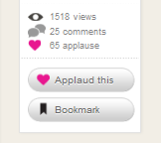

## Rules

1. Inspirations, comments and concepts can be applauded
2. Applause let’s user’s know others support them
3. Applause is not a popularity poll, but about appreciation

## Tasks

1. Help us choose the shortlist by applauding and commenting on your favorite concepts
2. Have a little think about applause you give
3. Keep up those conversations – they fuel fresh thinking!

## User experience in Applause phase

Applauding a concept or inspiration was one of the first actions I took on the challenge. The first action makes the terms and conditions for the challenge (different from general terms and conditions of the site) pop up and they must be accepted before continuing. I accepted them without reading. In the official applause phase I had to force myself to do the applauding. Another participant also mentioned in the comment section of a concept that many people disappear applause time, and that he too has to motivate himself to do it. I did most of the applauding during one visit. I browsed through all the concepts, opened the interesting ones and applauded the ones I liked. I found it hard not to look at the number of applause the concepts had already gathered, and it felt like seeing the current number had an effect on my decisions. I noticed I applauded the concepts both for “right” and “wrong” reasons. The “right” reasons include

* Great story
* Lots of effort on concept and nice video
* Based on feeling, headline and summary
* Last concept on the list, had been featured, someone had called it great and the word startup was mentioned
* Skimming through the concept and liking it
* Remembering seeing the concept before, now liking it
* Appreciating the effort
* High number of views and applause already
* Good problem definition, but didn’t read

On the other hand, the reasons to applaud that can be considered to be “wrong” include

* Not applauding a concept because it already had many applause and I was jealous
* Submitted by IDEO, Palo Alto, mentions games and Brainstorm-in-a-box was used
* Out of pity. The concept did not have any applause or comments before
* Did not applaud another concept because the user looked like the one who received the pity applaud
* Did not like the concept, but still applauded
* New technology mentioned, but I did not understand the concept, and did not care

During the applause phase I also had an opportunity to refine the concept I submitted to e-waste challenge. A facilitator commented on my concept and said she liked how it could be combined to many other ideas. I thanked for the compliment and asked if anyone had any specific suggestions to which ideas my concept could be replied. Another user wrote two comments suggesting many possible concepts to combine with. Reading the concepts and accompanying discussions was some work. I then used sticky notes to figure out how concepts could be combined. The updated concept was quite nice in my opinion. It had a new image and all. It was the achievement of the day. I also replied to a few other comments on my concept. This was the most active discussion I had on the site. In the end my concept did not make it to the shortlist.

# Shortlist selection

Before refinement phase the facilitators of OpenIDEO read through all the concepts and comments and take note of the applause given for the concepts. Number of applause and comments are used to help selecting the shortlisted concepts, but the facilitators still read trough everything to spot the hidden gems. Typical challenges have between 100 and 300 concepts, around 600 being the maximum so far. Going through all of them requires a lot of effort, but presumably it is not overwhelming, especially if several facilitators can be used.. According to my best estimate there are currently seven people working at least part-time as OpenIDEO facilitators. Representatives of the sponsor participate to decision-making and usually 20 concepts are selected on the shortlist. The owners of these concepts are asked to refine them in the next phase. The general impression is that the concepts are selected on the shortlist based on the merit the decision makers see in them, but there was also at least one exception. Job interviews as learning experiences was apparently selected on shortlist almost solely on the basis of amount of applause and comments. It sure is a much shorter and simpler compared than most other concepts that make it to the shortlists.

## Rules

1. Knowing we can’t decide the shortlist on our own, we also looked to you during applause phase

## Tasks

1. Review concepts and what community has to say about them
2. Make a shortlist for refinement
3. Name some concepts as honorable mentions that could be incorporated into shortlist concepts
4. Announce shortlist of OpenIDEATORS who will be asked to refine their concepts further with the help of community

# Refinement

In refinement phase the shortlisted concepts are improved upon in a collaborative fashion. Users can update their concept based on the feedback from facilitators and comments they have received from other users. Users may develop rough prototypes of their concepts, such as simple websites and mock-ups. Some of the users go much further still, especially in cases where they are actually planning to implement the concept on their own. Comments and discussion between participants play an important role in development of the concepts.

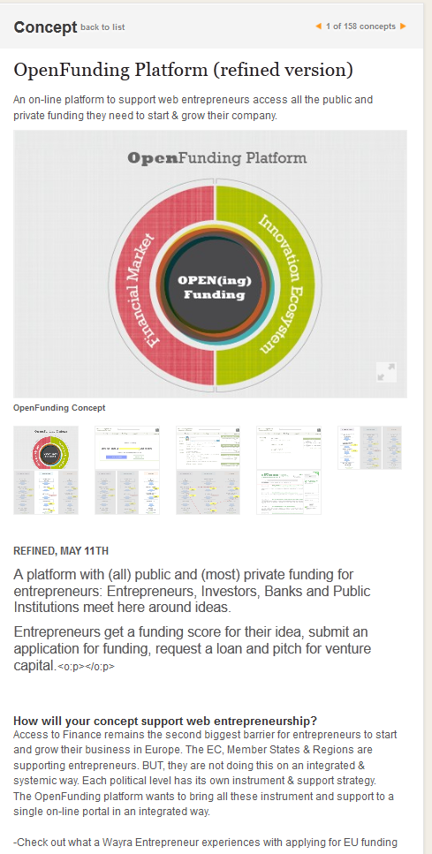 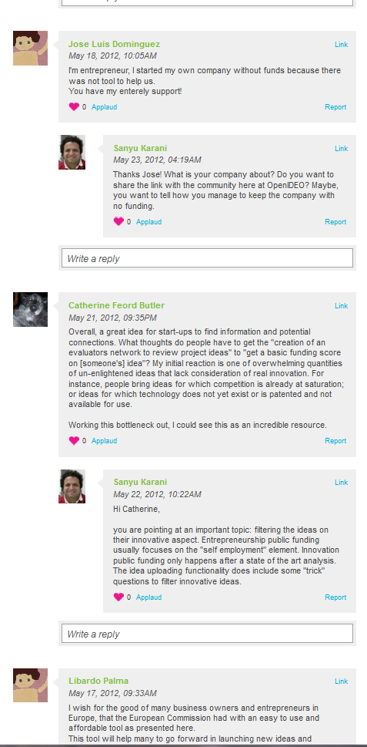

## Rules

1. We’ll focus our efforts on iterating, editing and prototyping our shortlisted concepts
2. Refining is as much about adding more detail as it’s adding clarity
3. Consider design constraints, such as how local ventures could be incentivized to be part of this venture, minimum viable product, and distinct moments instead of whole journey
4. Bring an eye for clarity and specifity. Remember that sometimes less is more
5. All good things start with a prototype. It might be rough, but we know you’re forgiving

## Tasks

1. Collaboratively strengthen shortlisted ideas, helping them achieve even greater impact
2. Get ready to fine-tune your submissions and add virtual team members, create visuals and experiment early prototypes
3. Get ready to hit that update entry button and iterate your concept even further
4. Further develop your idea to make it more robust
5. Bring clarity and specifity to your concepts
6. Update your posts based on discussion and suggestions
7. Build away!
8. Post your thoughts on this particular concept
9. Clarify this specific aspect of your concept
10. Consider these questions regarding your concept
11. Take a look at this related concept
12. Try to combine your concept with this
13. Check this out for more information
14. You should look at my concept, and please if you can add details

## User experience in refinement phase

I still have the feeling that OpenIDEO is a lot of work. The tasks are rather ill-defined, and the user needs quite a lot of skills and personal commitment to participate. The user has to be active and figure out on his own how exactly to contribute. This is true especially in refinement phase. Just reading through the potential concepts takes time. It feels like everyone has to do a lot of work to get the understanding of the whole issue, and then understand the whole concept they are developing to contribute meaningfully. I browsed through all the concepts that made it to the shortlist, which got boring in the end, and as a result I was not very thorough all the way through. Still, this gave me an overview on what kinds of ideas there are on the shortlist. Then I tried to figure out to which concepts I might have something to contribute. I noticed that OpenIDEO provides very good feedback for shortlisted concepts in the comments section on how to develop the concept further. Specific questions to be answered and links to refinement instructions direct the development. It seems like there is not much activity on the site during the refinement phase. Only 20 concepts made it to the shortlist, but still I cannot find much discussion. For example in one concept the latest comment was from OpenIDEO announcing that the concept had been selected to shortlist, and at that time there were only three days of refinement phase left. According to activity feed the tenth last activity took place yesterday. All this makes me wonder how active the OpenIDEO site actually is. It definitely looks like there haven’t happened much since the announcement of the shortlist. Is this typical? A contrasting viewpoint can be found in an older blog post, where a featured user describes especially the refinement phase being intense.

**Difficult tasks**

Tasks in refinement phase feel very difficult and poorly defined. I checked out the refinement instructions, and according to them this phase is a lot about visualization, clarification, mock-ups and prototypes. I'm getting somehow fed up with the platform. To contribute something, I would need to read through many long concepts and discussions to find those I have skills and knowledge to participate. Then I would need to take up a serious challenge of figuring out a business model or something else very challenging and time consuming. Creating a prototype is asked for in Verified Skills Academy. I considered this one to be barely within the limits of my skills, if I used Webbly. Golden e-waste concept is very long, and as a next step it would require a more honed business model and a pitch to investors. That’s too much to ask. Regenerate concept would also need refinements in the business model, which feels very difficult. In Digital data transfer and elimination services doing a survey on user perceptions is asked for. A few other concepts are also lacking a business model. It feels like participating to refinement seriously requires real commitment. I would only put in that much effort if I were planning to turn a concept to my own business. This makes me think that maybe OpenIDEO actually works by connecting the people who are already working on these concepts and bringing them together on a common platform.

In the end I did not really participate to refinement phase, even if I was supposed to. There was not much going on at the site, at least around the concepts I was interested in, and the required tasks were dauntingly big and challenging considering the little time I've had lately. Still, I’m wondering whether I am somehow biased in thinking that OpenIDEO is a lot of work to participate.

# Evaluation

In evaluation phase users are asked to evaluate all the shortlisted concepts against a specifically developed evaluation criteria. Facilitators define the evaluation criteria before the evaluation phase, possibly with the help of challenge sponsor. Similar to other instructions the evaluation criteria are defined behind the scenes by OpenIDEO facilitators, possibly in collaboration with the representatives of the sponsor and posted to the site in the beginning of the evaluation phase. A specific evaluation form is used for evaluation, which usually features 3-5 questions and numerical evaluation for each on multiple criteria.

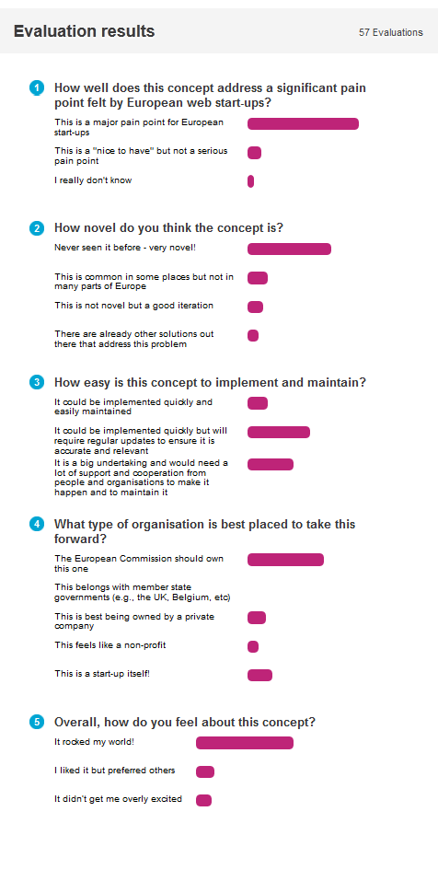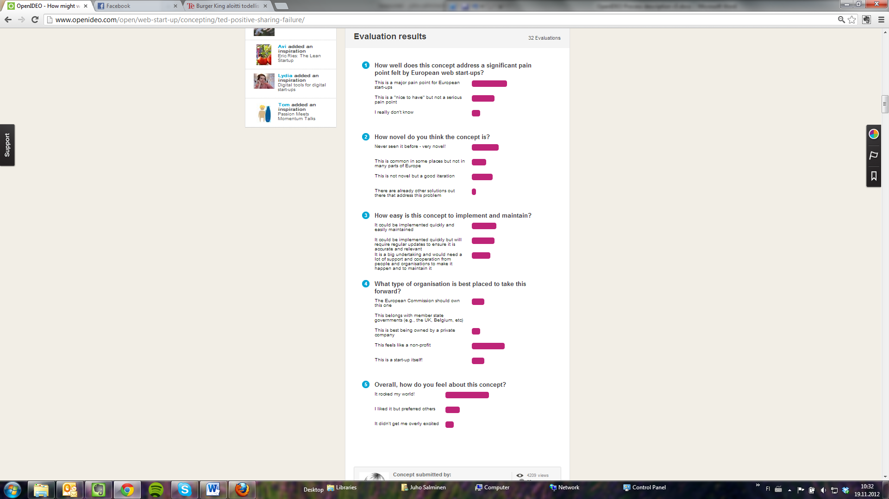

Examples of evaluations.

## Rules

1. Have you got what it takes?
2. Evaluate all shortlisted concepts
3. Evaluation is not a popularity poll
4. Focus your evaluative goodness on what matters: increasing social impact

## Tasks

1. Help select winners from the shortlist concepts
2. Spread the word
3. View the evaluation video
4. Objectively evaluate ALL shortlisted concepts
5. Think first about how a particular concept fits the needs of the challenge and then how concepts fit together
6. Assess the shortlisted concepts specific criteria, such as impact, feasibility and scalability

## User experience in Evaluation phase

I'm suspecting Unemployment challenge evaluation phase was extended. Suddenly there was again 10 days more time left. The site does not feel very active compared to Quirky. Only thing left for me to do is evaluate concepts. I could also comment on applaud them, but I do not feel like doing it. When I was first exploring the site, I saw a user stating that one should first read trough all the concepts and then think about them, and evaluate all the concepts, but I don't think I want to do that. I just want to get something done quickly. First I decided to start evaluating concepts in order and continue as long as I feel like it. Evaluation questions felt a bit confusing. Results are shown only after I finish evaluation.

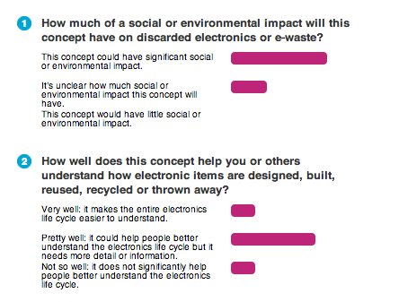

Pressing back button after evaluating a concept returns the user to the concept list, the order of which is randomized. I decided to evaluate the concepts that have the least evaluations. Most of the time I just skimmed the concepts and evaluated them based on the first expression. Again, my evaluations were inconsistent and subjective. I found it difficult to be critical. Even if I did not like the concept I often gave it mid-range evaluations just to cheer the submitter up. Once I gave very positive evaluation partly because the concept was similar to my concept that did not make it to the shortlist. If the concept was long I only skim-read it, and skipped evaluating one particularly long concept. It would have been unfair to evaluate it without even reading it. In general, I did not put much effort to evaluations. Making the choice between the options was not difficult: only three options, and the wording of choices makes it most of the time easy to select one of them. The choices I made might even have depended more on the wording of choices than the merits of the concept. Perhaps I evaluated the wording instead of the actual concept?

I got a feeling the problem definition is the difficult part in the OpenIDEO challenges. It feels like people do not get it right, because there are usually so many interacting issues. I have seen several concepts on the shortlist I consider doomed. They just do not make sense when the incentives of companies and different interest groups, or the huge hassle of designing logistics to upgrade electronics en masse are taken into account.

# Decision on winners, reporting

Facilitators of OpenIDEO decide the challenge winners in collaboration with the representatives of the sponsor. Evaluations by users support the decision making, but do not dictate the results; selecting winners is repeatedly described as a difficult task and it does not strictly follow the order of evaluations (check this! Also, what is the order of evaluations?). Depending on the challenge a report may also be prepared, and in one anecdotal case IDEO used the platform to support its own project work. Results from the challenge were included in the project report

## Rules

Unknown.

## Tasks

1. Sort through concepts
2. Pore through inspirations, concepts, comments and evaluations
3. Read them all
4. Select winners with the sponsor
5. Announce winners

# Winning concepts

In this simple phase the winning concepts are announced on the site. Except for the glory and congratulations from the community the winners are not rewarded, although sometimes regular winners and active participants are featured in the site blog in a short interview.

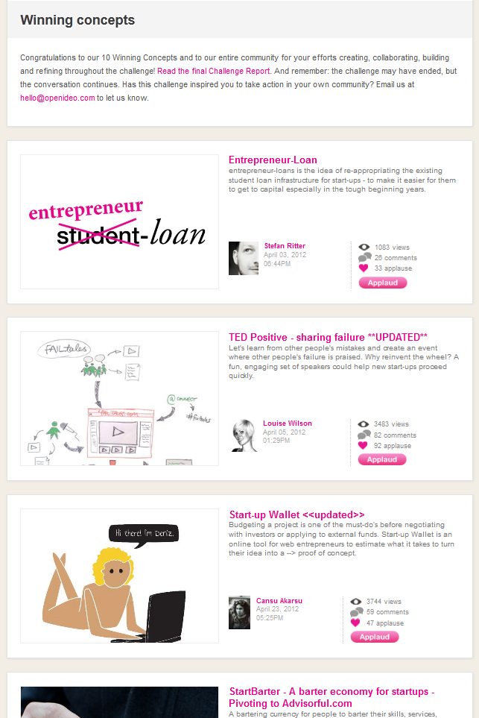

# Implementation by sponsor and participants

Implementation of developed concepts is outside the scope of the platform. Challenge sponsors may implement some of the concepts, but much information is not available. Users of the site are encouraged to try implementing concepts by themselves, and some of them do indeed build prototypes and test and develop them in their own communities.

# Realisation

The last phase of the OpenIDEO innovation process is realization. Realisation phase is about telling stories and dissemination of information about implementation taking place outside the site. The users are asked to submit their stories of successfully implemented concepts and then the site works as a platform to disseminate information about concepts that are going forward. The OpenIDEO does not implement anything on its own.

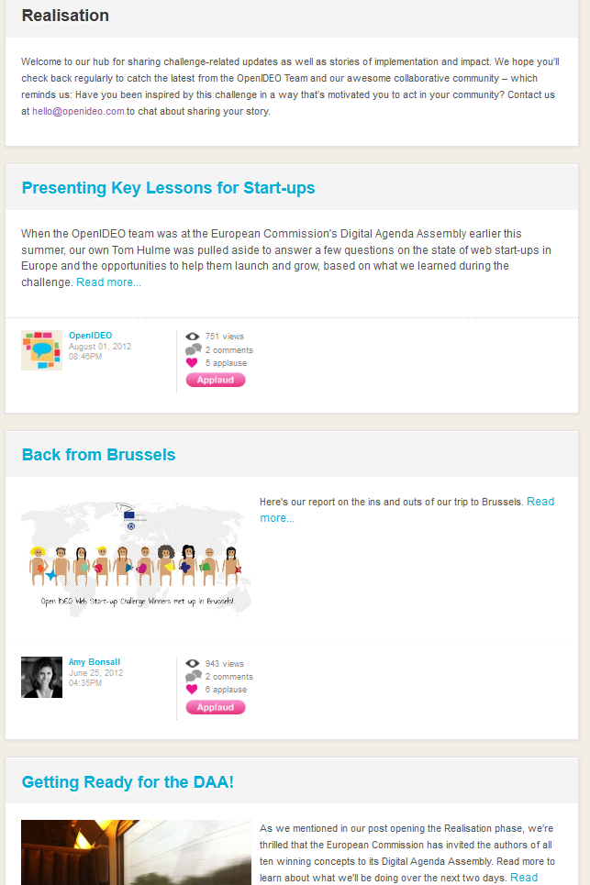

## Rules

1. As the sign says: implementation = hard work ahead
2. Remember: challenge may have ended, but the conversation continues
3. Sharing stories of implementation: we all know this is a significant part of pursuit for social good
4. Realisation will enable to share implementation progress with OpenIDEO community
5. Impact stories, big or small, are all worth celebrating
6. Others inspired to action

## Tasks

1. Do not forget about challenges, which are now in realisation
2. Challenge may have ended, but our collaboration efforts and conversations continue
3. Build on the concepts you see here
4. Share this with an entrepreneur – Steal this idea!
5. Contribute to this particular project we are working on (user)
6. Has this challenge inspired you to take action in your own community? Email use at <address> and let us know